Assignemnt-11

ROLL NO 102316007

1P11

QUESTION 1

Design a Cognitive Assistant for Reading Labels of medicine bottle (You can download

Dataset from Internet)

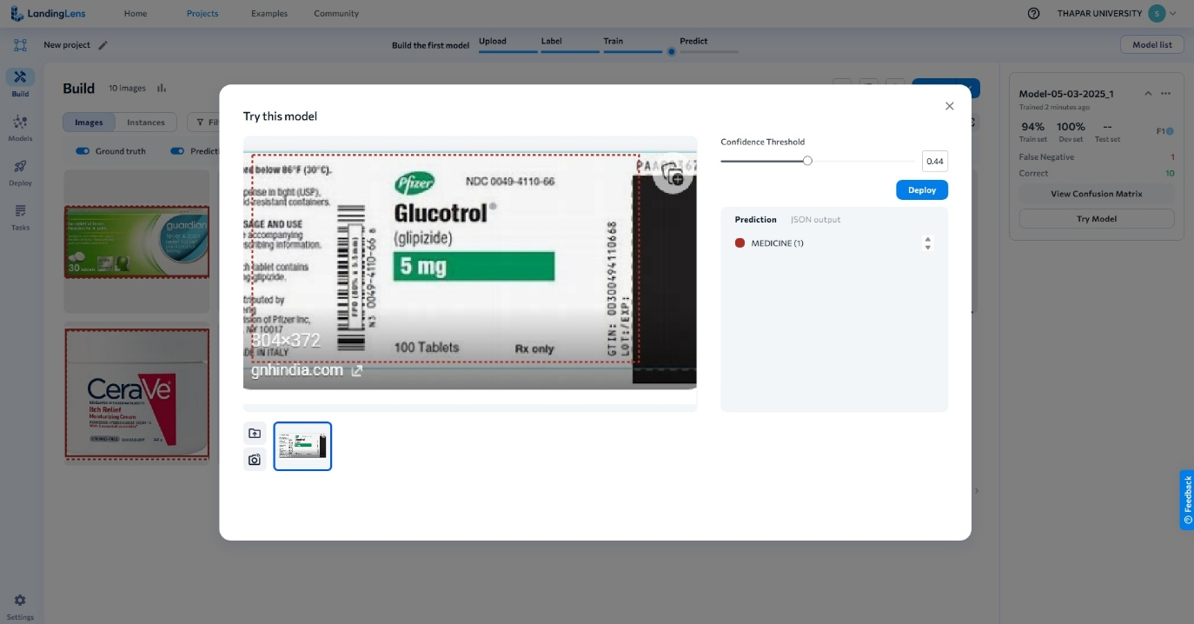

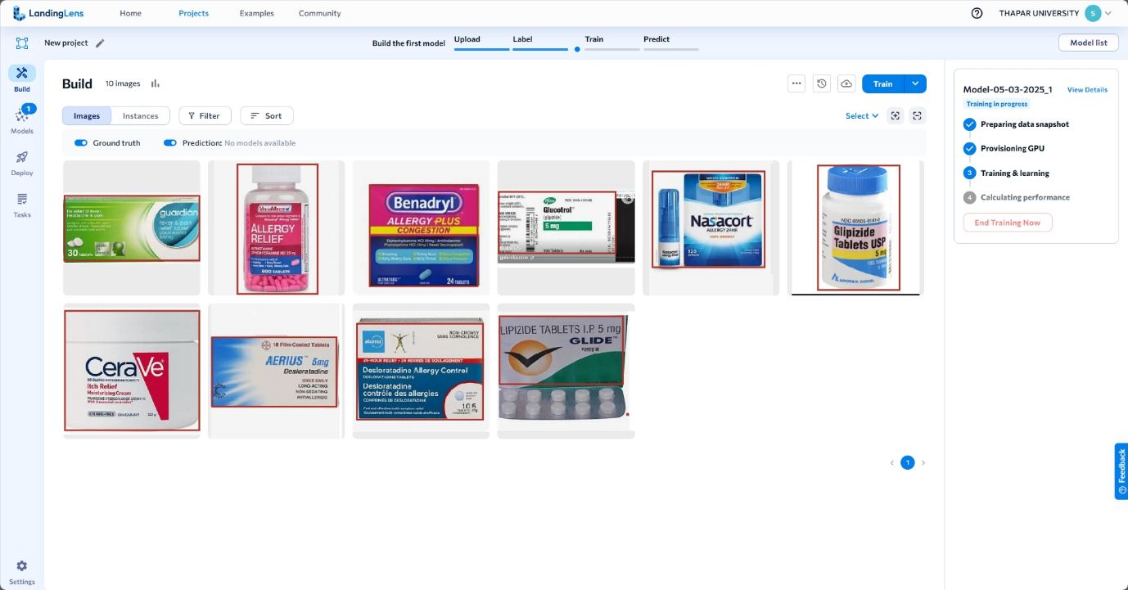

QUESTION 2

Design an Emotion-aware Cognitive Assistant using Facial Expression Detection

